Dear AMS Member,

In these unprecedented times, please find below the latest news and announcements from the Society.

Stay safe, stay well, and if possible, stay home.

Regards,

Leona Campbell
President, Australasian Mycological Society

Cancellation of the AMS Scientific Meeting, Hobart 2020 & Expressions of Interest for an Online Scientific Meeting.

Due to the COVID-19 crisis we have unfortunately, had to cancel the upcoming 2020 AMS Scientific Meeting, which was to be held in Hobart, 10th & 11th July, 2020. This meeting will be rescheduled for 2021.

As many of us adapt to working in an online world, we would like to survey our membership regarding an online scientific meeting. If you (or your students) would be interested in participating in a meeting with this format, please let us know by contacting Jeff Powell (jeff.powell@westernsydney.edu.au).

Threatened waxcaps (Hygrocybe) research opportunity in Greater Sydney

The NSW Mycology Herbarium and the Biodiversity and Conservation Division of Department of Industry, Planning and Environment are collaborating with Western Sydney University to develop a genetic biobank of threatened Hygrocybe within Greater Sydney. There are nine species of threatened fungi and a Critically Endangered Hygrocybeae Community of Lane Cove Bushland Park, from the family Hygrophoraceae found within the Sydney Basin IBRA Region. The nine listed fungi include: Hygrocybe collucera, Hygrocybe griseoramosa, Hygrocybe lanecovensis, Camarophyllopsis kearneyi (endangered) and Hygrocybe aurantipes, Hygrocybe austropratensis, Hygrocybe reesiae, Hygrocybe rubronivea, Hygrocybe anomala var. ianthinomarginata (vulnerable). The Threatened Ecological Community is comprised of more than 30 species of fungi in the family Hygrophoraceae. More information on the TEC can be found here. This project is funded under the NSW Government Saving our Species Program. Further information on this program the Hygrocybe project can be found here.

The conservation project aims to maintain Hygrocybe diversity and extent and habitat (vegetation and soils) at priority sites. To achieve this, we require a basic understanding of the existing Hygrocybe diversity and distribution at each. As such the NSW Government has partnered with the NSW Mycology Herbarium and Western Sydney University to pair morphological identification of samples with DNA sequencing and develop a reference collection and DNA Biobank.

Various opportunities exist to partner in this project:
- as a research partner (honours, masters or PhD) investigating threatened Hygrocybe distribution and diversity, developing a Hygrocybe DNA biobank and reviewing Hygrocybe identification and classification
- as an expert with knowledge on threatened Hygrocybe in greater Sydney providing advice on threatened Hygrocybe distribution and diversity within Greater Sydney
- as on-ground field support for surveys across greater Sydney during April- August 2020.

For further information on this project please contact Jordan Bailey jordan.bailey@dpi.nsw.gov.au or Meagan Hinds Meagan.Hinds@environment.nsw.gov.au or Jeff Powell Jeff.Powell@westernsydney.edu.au.

Mycologist position advertised at Royal Botanic Gardens Victoria

An ongoing position for a mycologist has recently been advertised at Royal Botanic Gardens Victoria. "The Research Scientist (Mycology) will be responsible for conducting original research on taxonomy and systematics of fungi. Essential for the position is expertise in the taxonomy, systematics, nomenclature and conservation of fungi. The Research Scientist will be a recognised authority in specialist areas of fungal taxonomy and systematics using morphological and molecular approaches in a collections-based workplace." The position has become available due to the resignation of Dr Teresa Lebel (who has taken up a position at the State Herbarium of South Australia). Closing date for applications is 8 May. See: https://careers.vic.gov.au/job/research-scientist-mycology-453640.

Fungi Portrait, April 2020 – Syncephalastrum contaminatum, a new zygomycete found as a laboratory contaminant

Numerous new species of fungi are described each year, mostly in the Dikarya (Ascomycota and Basidiomycota). Andrew Urquhart and Alexander Idnurm add to the knowledge of the Mucorales (Mucoromycota) by describing a new species of Syncephalastrum found as a contaminant of a laboratory culture of another fungus. Four sporangiospores are formed in each merosporangium. Morphological characters are very similar to other species of Syncephalastrum, but the ITS sequence is distinct from the three other species described so far in the genus. A complete genome of the novel fungus was obtained through Illumina sequencing. The structure of the sex locus suggests that Syncephalastrum contaminatum is heterothallic. The natural area of distribution and the ecological preference of the fungus remains unknown.
Urquhart AS & Idnurm A (2020) Syncephalastrum contaminatum, a new species in the Mucorales from Australia. Mycoscience,https://doi.org/10.1016/j.myc.2020.02.003 https://www.sciencedirect.com/science/article/pii/S1340354020300188

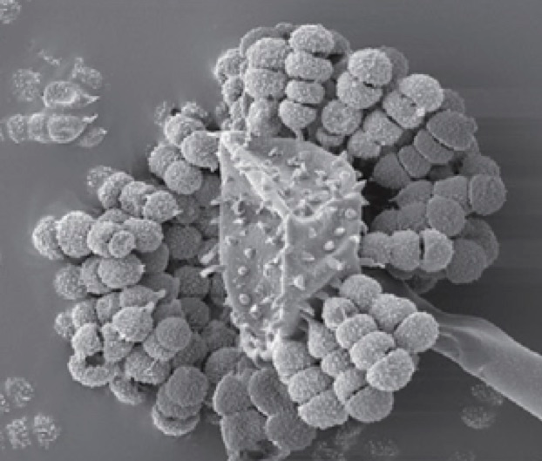
Scanning electron micrograph of four-spored merosporangia arising from terminal enlargement of the sporangiophore of Syncephalastrum contaminatum.

Note that past Fungi Portraits are now available on the AMS website. Thanks to Tom May for providing our Fungi Portrait articles.

Regards,

Leona

